Visit of Andorra Omorodine Collins

What is the population of Andorra?
A] 84,082
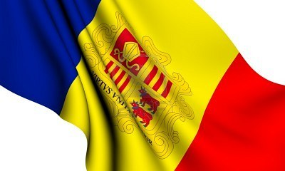
B] 12’ooo
C] 78.209

You pay in
A]dollars
B]pesetas
C] euros

THE OFFICIAL LANGUAGE IS
A]French
B]Spanish
C]Catalan

The colours of the Andorran flag are:
A] blue ,red ,yellow
B] black,red,green
C]white, brown, red

The capital of Andorra is:
A]Encamp
B]Sant Julia
C]Andorra la vella

Where is Andorra ?
A] between Spain and Portugal
B] between Spain and France
C]between Portugal and France

How many parishes are there?
A]12
B]7
C]5

