Andorra

1/What is the language:
- French
- Spanish
c) Catalan

2/The head of the government is:
a) the prime minister
b) the king

3/You drive:
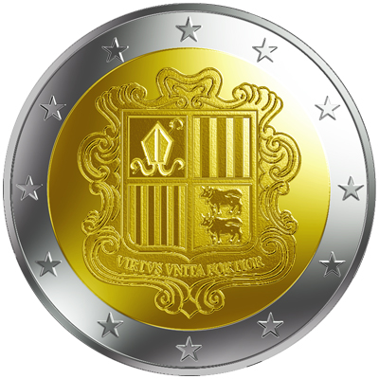
a) On the left
b) On the right

4/You pay in:
a) Euros
b) Dollars
c) Pounds

5/Andorra is a country famous for its:
- politics
- agriculture
- tourism
6/This country is
- very rich
- moderately rich
- poor

7/The population is approximately:
a) 84.825
b) 75.632
c) 38.684

8/ The climate in Andorra is:
- hot
- moderate
- cold
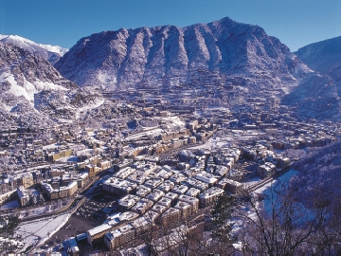
9/The area of Andorra is :
- 5673km
- 468km
- 45367km

10/On summer evenings, a music and dance festival is held in :
- Andorra la Vella
- Escaldes
- La Massana

Bryan Vieira 3A

