Quiz about andorra
10
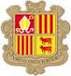
Juan Balaguero
3ºA

1. Andorra is famous for:
a) its cars
b) its tourism
c) its universities

2. You pay in:
a) in dollars
b) in pounds
c) in euros

3. How many parishes are there in Andorra?
a) 8
b) 12
c) 7
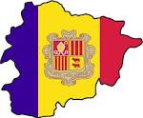
4. What colour is the Andorran flag:
a) White, black, purple
b) Blue, yellow, red
c) Blue, white, yellow

5. You drive:
a) on the left
b) on the right

6. What climate is there in Andorra?
a) mediterranean
b) tropical
c) oceanic

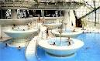
7. Where is Andorra?
a) In THE south of Europe
b) BETWEEN Spain and France
c) In THE north of Asia

8. caldea is in:
a) pas de la casa
b) ordino
c) escaldes

9. The official language in Andorra is:
a) german
b) spanish
c) catalan


10. The capital of Andorra is:
a) Encamp
b) la massana
c) Andorra la vella

1-b 2-c 3-c 4-b 5-b 6-a 7-b 8-c 9-c 10-c

