Quiz About Andorra.. Borges Ana 3A

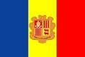
1- Where is Andorra?
- America
-Asia
-Europa
2-What climate is there in Andorra?
- mountain with oceanic
- pacific
- mountain with mediterranean
3-The population is approximately ?
- 84.082 people
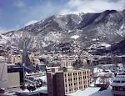
- 90.082 people
- 80000 people
4- The capital of Andorra is ?
- Escaldes-Engordany
- Andorra la vella
- Sant Julia De Loria
5- in Andorra you pay in:
- Pounds
- Euros
- Dollars
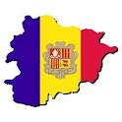
6-How many parishes are there in Andorra?
- 7
- 10
- 5
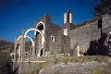
7- Andorra is in:
- theAlps
- the Pyrenees
- the Coma pedrosa
8-The heads of state are :
- The co-princes are José Vaquero and Jeans Bhon
- the co-princes are the Bishop of urgell and Nicolas Sarkozy

- The co-princes are Mario Marquez and José Zapatero
9-Legend in Andorra is ?
- That Louis VII founded Andorra
- that Charlemagne founded Andorra
- That Napoleon founded Andorra
10-What is the language in Andorra
- Spanish
- Andorran
- Catalan
11-How many colours are there in the flag ¿?
- 3
- 2
- 4
12- What are the colours in the flag?
- red, yellow, blue
- blue , white, red
- red, yellow, green
13- What is the typical sport in Andorra?
- bike
- ski
- rugby
14- In Andorra, you are an adult at the age of?
- 17
- 18
- 21
15- When is the national holiday ?
- In May
- in July
- in March
16- When is the feast day of st Meritxell?
- 9th September
- 10th July
- 28th January

