Andorra

- The population is approximately :
a). 84.825.
b). 74.201.
c). 80.825.

- The head of the government is:
a). The president
b). The general council
c). The prince

- You pay in :
a). Dollars
b). Pounds
c). Euros

- The official language is :
a). Catalan
b). German
c). French

- The colour of the flag of Andorra is :
a). Blue, yellow and red
b). Green, red and blue
c). Blue, white and red

- Where is Andorra :
a). Europa
b). U.S.A
c). Africa

- What is the capital of Andorra :
a). Sant Julia de loria
b). Ordino
c). Andorra la vella

- What is the typical animal in Andorra :
a). Dog
b). Horse
c). Mountain goat

- Has Andorra got a beach :
a). Yes
b). No

- You drive :
a). On the left
b). On the right

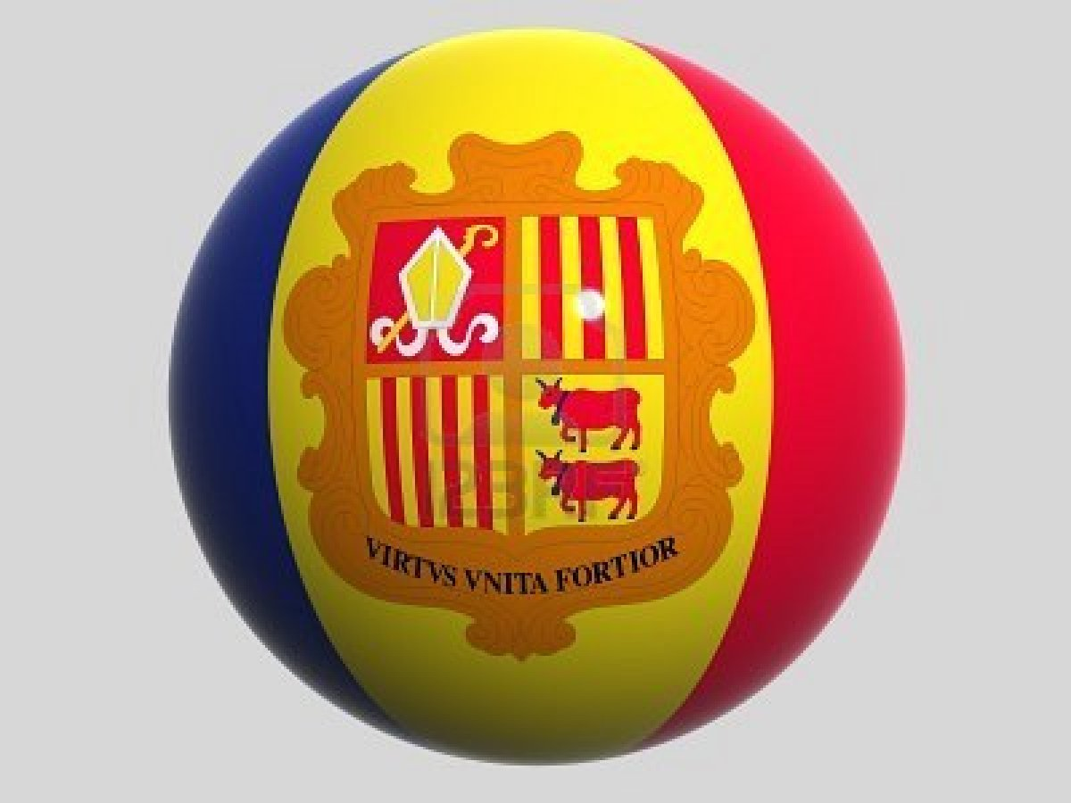

Aleix VILAMAJO 3A

