COSTA SILVA Gonçalo

Sex: Male

Occupation: Student in lycée comte de foix

Interested in: Rap music and sports

Birthay: 28 May

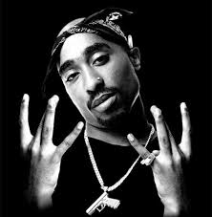

**November 8**

Hello i´m Gonçalo. I´m 15 and i Love RAP.

I lovely RAP music

I like with be friends

I like boxing and football

I don´t have brothers and sisters

I played in a club of football

I loves write song verses RAP

My best friend is Laura hes 14

And Joan she loves wind in class jajajaja and me