Sex: Female
Occupation: Student at Lycée Comte de Foix
Interested in: hanging out with friends/cousins
Birthday: December 3th
Hometown: Andorra, Andorra la Vella.

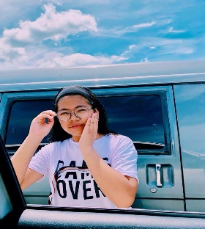
October, 12th
My Profile:
Hey, I'm Queenie! You can also call me Queen or Kenny. I’m 14 years old. I like meeting new friends/people. I have a sister and a brother, they're younger than me. I love listening to pop music. I also love animals. My favourite sport is skiing. I like hanging out with friends and I love traveling around the world. I love visiting new countries. And also, I love helping people. My favourite country is the Philippines. I want to visit Asia, Africa, and North America. Since I’m a full blooded Filipino, I have lots of relatives in the Philippines. I also have some relatives that live in California.

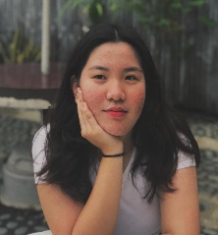
My bestfriend:
Here is my bestfriend Leyna. She is 13 years old. She's from another country, from the Philippines. She likes listening to music and she also likes reading. I met her on instagram thanks to my cousin. Soon, I’m gonna go to the Philippines to meet her for the first time, and I’m really excited! She's the best! Especially in my life, she's my other half. And she's really cute!

