My profile

Sex:Male  Occupation: student at Lycée Comte de Foix  Interested: football and hip hop music  Birthday: 2nd June | 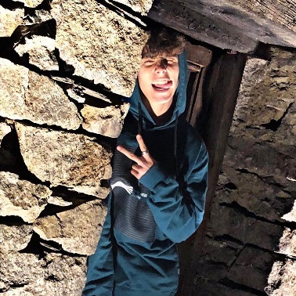
2nd October  Hi I’m Cristian. I’m 15 years old. I like surfing the internet because I like Instagram and WhatsApp. Here is my profile. I love playing football. I practice in a club. My team is Santa Coloma.  I like listening to music. I love trap music. My favourite singer is Paulo Londra. | 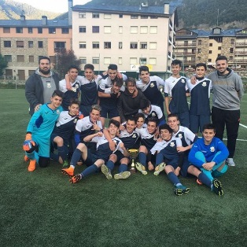  
Here is Tatiana, my girlfriend. She is 17. She loves me. She loves Paulo Londra she likes trap music and reggae. She also likes dancing. And she’s very pretty.

My best friend is Alex. He is 15. He loves playing tennis. He plays in a trap music group. We have been best friends sinice 2006/2018 | 

