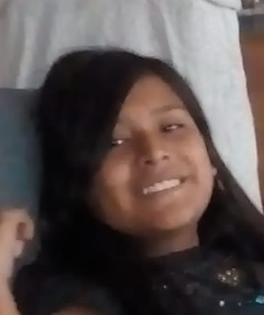Sex: **Female**

Occupation: Student at Lycée Comte de Foix

Interested in: boxing, volleyball

Birthday: 27th march

Hometown: Sant Julià de Lòria, Andora (AND)

October, 20

Hi I’m Maria. I’m 14. I like listening to music. Here is my profile.

I love volleyball and competition. I like boxing and I practice every thursday at Blog Café.

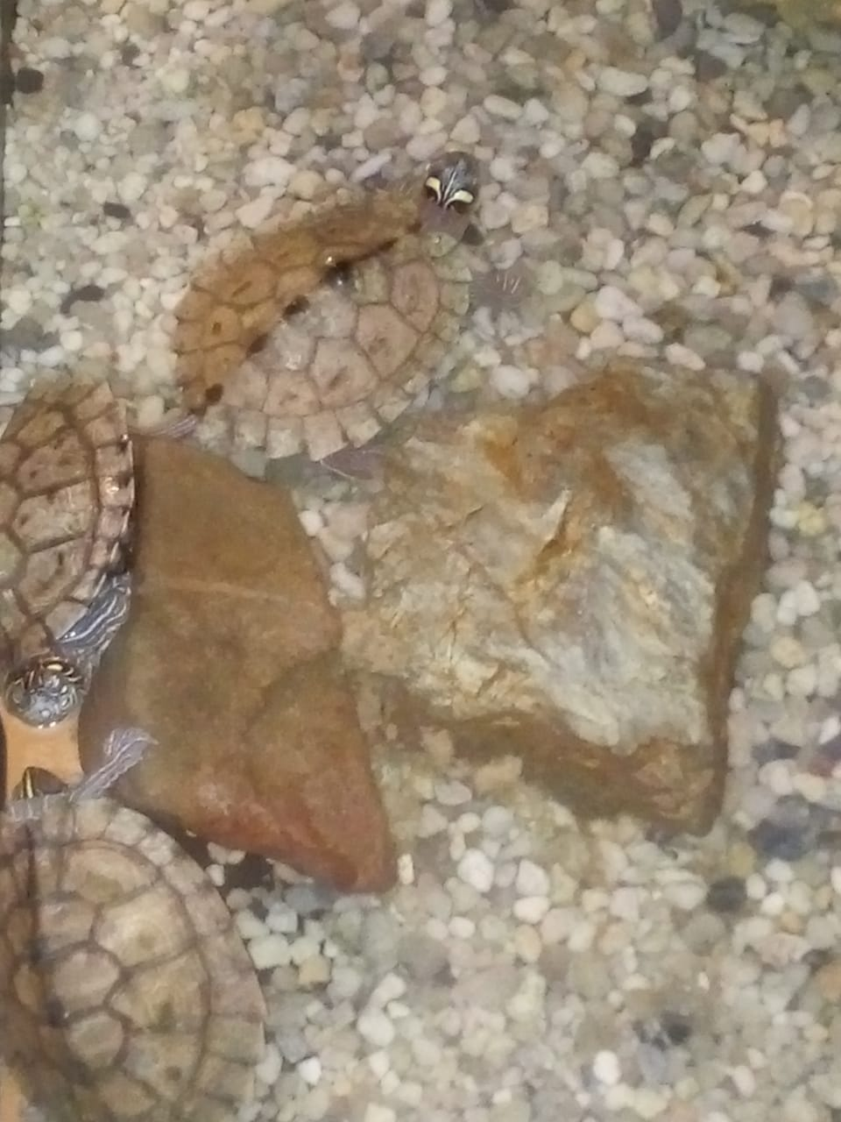

I have three turtles in an aquarium.

I like eating rice and eggs.

My favourite drink is “Inkacola” and my favourite dessert is “mazamorra morada”.

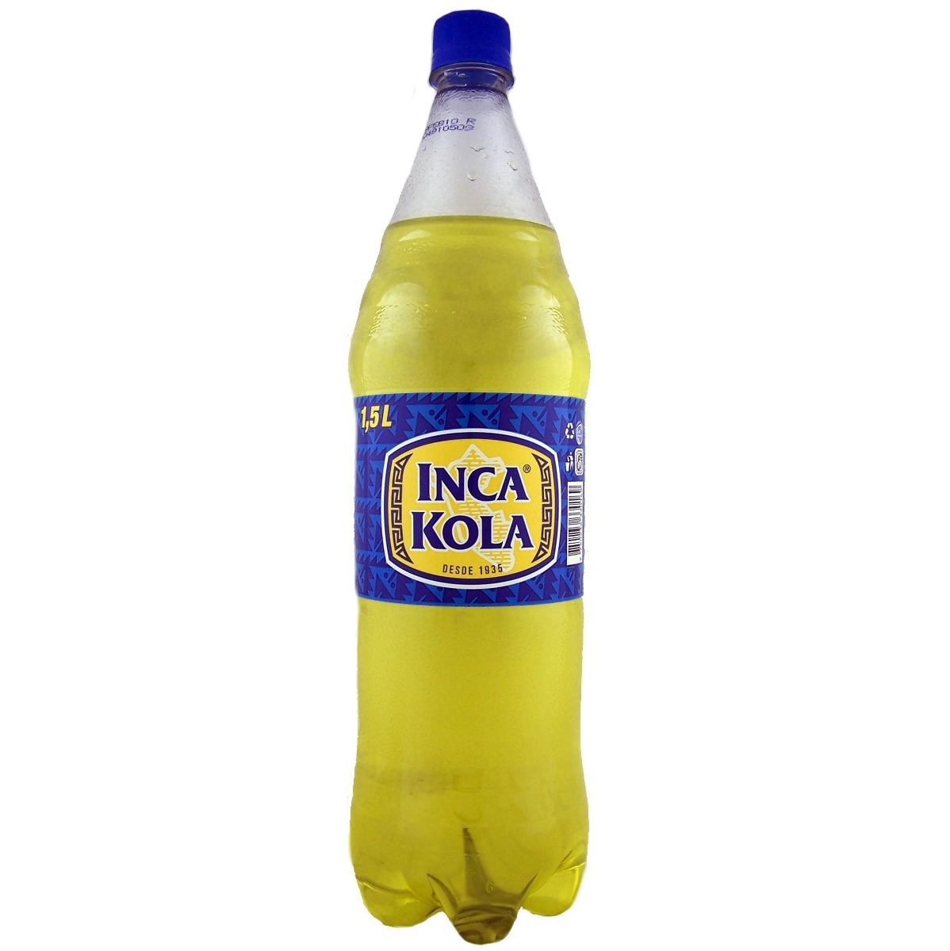

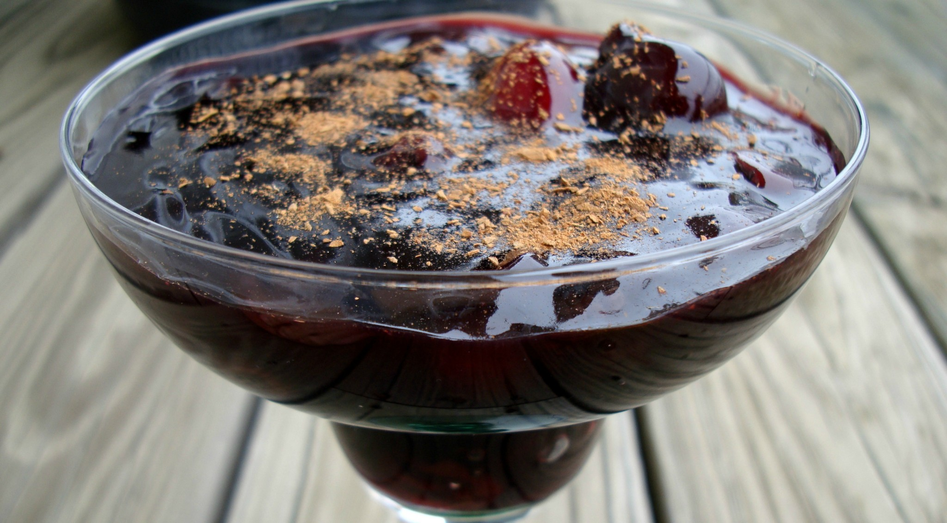

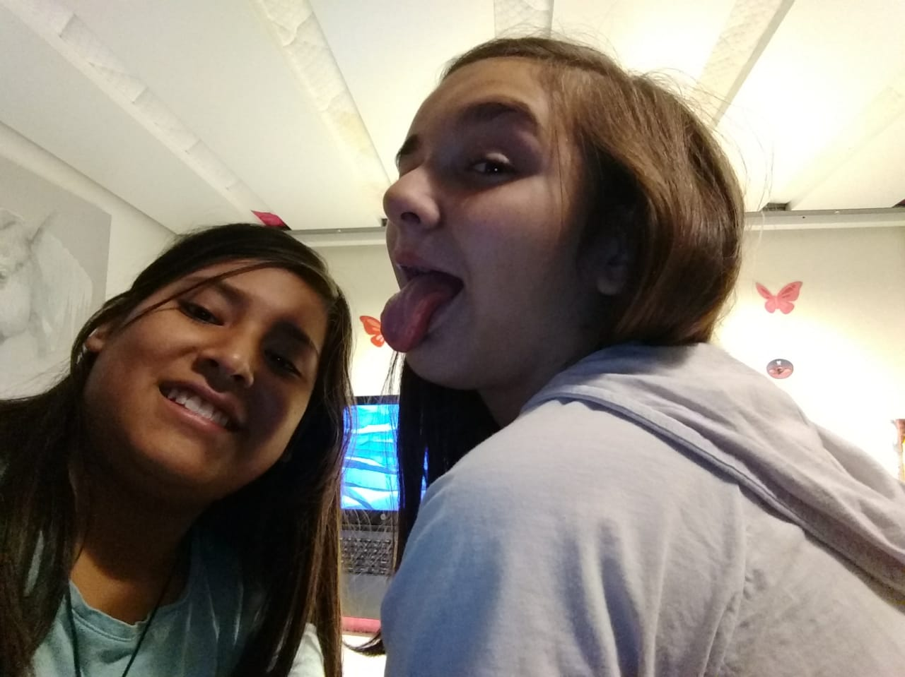

Here is Ainhoa, my best friend. She is 14. She loves boxing. She has a cat “orejas”. She doesn’t like dogs.

And you, do you like the same things?