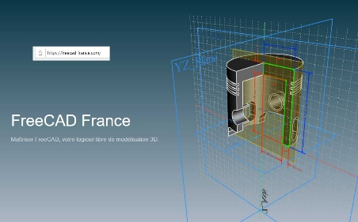 **FREECAD**

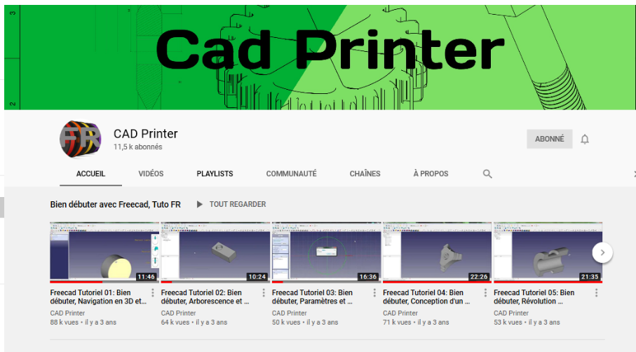 **Tutoriel 018 sur YouTub**

**(** [**Cad Printer – you tube**](https://www.youtube.com/channel/UChwUxlPx6EP4hKFQyA4rCuQ) **) ou**

[**https://www.youtube.com/channel/UChwUxlPx6EP4hKFQyA4rCuQ**](https://www.youtube.com/channel/UChwUxlPx6EP4hKFQyA4rCuQ)

**adresses vidéos**

**00**

<https://www.bing.com/videos/search?q=freecad+tutoriel+01&&view=detail&mid=2FEF1E24D7B684481ACF2FEF1E24D7B684481ACF&&FORM=VRDGAR&ru=%2Fvideos%2Fsearch%3Fq%3Dfreecad%2520tutoriel%252001%26qs%3Dn%26form%3DQBVR%26sp%3D-1%26pq%3Dfreecad%2520tutoriel%252001%26sc%3D1-19%26sk%3D%26cvid%3DEB7F39447D04487A89355DE0130F0567>

**01**

<https://www.youtube.com/watch?v=SCPF2ob3p1Y&list=PL1P4z1vfrsq8KZ2mHqRBZg8aoftq_w6vY&index=1>

**02**

<https://www.youtube.com/watch?v=FgznG3jlcGk&list=PL1P4z1vfrsq8KZ2mHqRBZg8aoftq_w6vY&index=2>

**03**

<https://www.youtube.com/watch?v=hB4oy_hd3X4&list=PL1P4z1vfrsq8KZ2mHqRBZg8aoftq_w6vY&index=3>

**04**

<https://www.youtube.com/watch?v=IlJnu-rXYOU&list=PL1P4z1vfrsq8KZ2mHqRBZg8aoftq_w6vY&index=4>

**05**

<https://www.youtube.com/watch?v=gTx6P5o1ubk&list=PL1P4z1vfrsq8KZ2mHqRBZg8aoftq_w6vY&index=5>

**06**

<https://www.bing.com/videos/search?q=freecad+tutoriel+06&&view=detail&mid=8825D04265DB71F409708825D04265DB71F40970&&FORM=VRDGAR&ru=%2Fvideos%2Fsearch%3Fq%3Dfreecad%2520tutoriel%252006%26qs%3Dn%26form%3DQBVR%26sp%3D-1%26pq%3Dfreecad%2520tutoriel%252006%26sc%3D0-19%26sk%3D%26cvid%3D1F1F8FE2AA0D46579EC0E9CEA266AD00>

**07**

<https://www.youtube.com/watch?v=PVYY-y1xPqc&list=PL1P4z1vfrsq8KZ2mHqRBZg8aoftq_w6vY&index=7>

**08**

<https://www.bing.com/videos/search?q=freecad+tutoriel+08&&view=detail&mid=DD31D8438F07E2B913E2DD31D8438F07E2B913E2&&FORM=VRDGAR&ru=%2Fvideos%2Fsearch%3Fq%3Dfreecad%2520tutoriel%252008%26qs%3Dn%26form%3DQBVR%26sp%3D-1%26pq%3Dfreecad%2520tutoriel%252008%26sc%3D1-19%26sk%3D%26cvid%3D9EC6E18CAD1A4108B2F04F3F5CBAC5D9>

**09**

<https://www.bing.com/videos/search?q=freecad+tutoriel+fran%c3%a7ais&qpvt=freecad+tutoriel+fran%c3%a7ais&view=detail&mid=0D03AA902FCC0A52303E0D03AA902FCC0A52303E&&FORM=VRDGAR&ru=%2Fvideos%2Fsearch%3Fq%3Dfreecad%2Btutoriel%2Bfran%25c3%25a7ais%26qpvt%3DFreecad%2BTutoriel%2Bfran%25c3%25a7ais%26FORM%3DVDVVXX>

**10**

<https://www.bing.com/videos/search?q=freecad+tutoriel+10&&view=detail&mid=A83B78AA5F6FE11467FEA83B78AA5F6FE11467FE&&FORM=VRDGAR&ru=%2Fvideos%2Fsearch%3Fq%3Dfreecad%2520tutoriel%252010%26qs%3Dn%26form%3DQBVR%26sp%3D-1%26pq%3Dfreecad%2520tutoriel%252010%26sc%3D0-19%26sk%3D%26cvid%3D3CD057E15F9A424D9D5911A4E1779F18>

**11**

<https://www.bing.com/videos/search?q=cad+printer&&view=detail&mid=6BA67BAB467A7422D1F96BA67BAB467A7422D1F9&&FORM=VRDGAR&ru=%2Fvideos%2Fsearch%3Fq%3Dcad%2520printer%26qs%3Dn%26form%3DQBVR%26sp%3D-1%26pq%3Dcad%2520printer%26sc%3D4-11%26sk%3D%26cvid%3D77CCC7B1C8264500874E2EA5FDB8D2F0>

**12**

<https://www.bing.com/videos/search?q=freecad+0.18+en+fran%c3%a7ais&&view=detail&mid=C058BD1F633166BE5E32C058BD1F633166BE5E32&&FORM=VRDGAR&ru=%2Fvideos%2Fsearch%3Fq%3Dfreecad%2B0.18%2Ben%2Bfran%25c3%25a7ais%26qpvt%3Dfreecad%2B0.18%2Ben%2Bfran%25c3%25a7ais%26view>

**13**

<https://www.bing.com/videos/search?q=freecad+tutoriel+13&&view=detail&mid=31900F7DC4A49A06F33031900F7DC4A49A06F330&&FORM=VRDGAR&ru=%2Fvideos%2Fsearch%3Fq%3Dfreecad%2520tutoriel%252013%26qs%3Dn%26form%3DQBVR%26sp%3D-1%26pq%3Dfreecad%2520tutoriel%252013%26sc%3D1-19%26sk%3D%26cvid%3DE76D1C2A3B8B42CA99D258EC44DFEF4D>